# The Gift of Health

Priceless

|  |  |  |  |  |
| --- | --- | --- | --- | --- |
|  |  | |  | | --- | | Christmas Gift Ideas  On a Budget | |  | |
|  |  |  |
| let’s thrive together! |  | happy holidays |

Creating your own gifts is a great way to demonstrate care. They can be personal, fun and healthy when you give chemical-free, nourishing, healing essential oils. They are also easier on tight budgets without compromising quality.

Did you know the average woman applies over 300 chemicals a day to her body just through soaps, makeup, shampoo, and hair care products?  Eighty of those products are applied before breakfast!

The Environmental Working Group is an independent website that sifts through product ingredients to help keep consumers aware of dangerous ingredients in commercial products. You can also search for health warnings by governments and independent organizations such as the Lung Association and Cancer Research Foundation among others.

Check the products you are using and gifting to see if they contain ingredients with health warnings. Support wellness for your loved ones.

Not all Oils are Equal

Many companies increase profits by spraying crops with pesticides to get a higher yield or using chemical solvents to extract the oils and then dilute them with cheaper 2nd and 3rd distillations or inexpensive fillers. Many essential oils are sold more cheaply because companies cut corners.

When shopping for oils and natural products, I landed with Young Living because of their seed-to-seal commitment. Young Living oversees every step to ensure the soil, seeds, distillation process and final product are beyond organic and are gently extracted to retain all the therapeutic compounds necessary for wellness support.

Here are some ideas for transforming essential oils into great gifts.

## **SUGAR SCRUB**

¼ cup + 2 T Young Living V-6 Oil Complex or Coconut Oil

5 drops Bergamot or Lemon

3 drops Lavender

2 drops Frankincense

2 drops Wintergreen or Peppermint

¾ cup raw sugar

In a small bowl, mix carrier oil with essential oils. Add mixture to raw sugar in a larger bowl and combine thoroughly. Store in a short, wide-mouth airtight jar. Top with a ribbon and gift label and you have a gift ready for a teacher, Mom, teen, or Neighbour.

## **BEAUTIFUL NAILS**

In a 2oz Dropper Bottle

3 drops Lavender

3 drops Lemon

3 drops Rosemary

3 drops Frankincense or Geranium

Top off with Jojoba or Argon Oil and apply to nail bed daily

If you have no time for a DIY but want to give a nourishing body lotion. Young Living has a great selection of hand and body lotions. Link here - https://m.lfstps.com/XhGm/fwQ 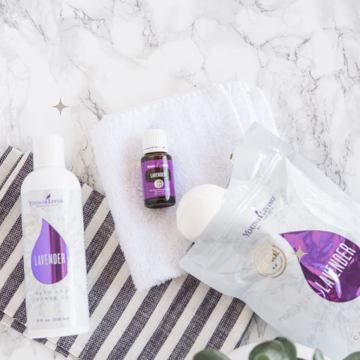

Gifts for Getting Active:

**MUSCLE MAN MIX**

Make your own custom blend in an empty 15 ml bottle and top it with a roller fitment.

20 drops Lemongrass

20 drops Copaiba

20 drops Idaho Blue Spruce

20 drops Wintergreen

20 drops Peppermint

Top with Carrier Oil and apply generously after shovelling the driveway or working out.

OR USE:

**MUSCLE RUB #2**

6 drops Frankincense

6 drops PanAway

6 drops Peppermint

6 drops Copaiba

6 drops Wintergreen

Stir essential oils into ¼ cup softened coconut oil. For a creamy texture add ¼ cup shea butter.

OR

**TENSION ROLLER**

10 drops Pan Away

10 drops Peppermint

10 drops Copaiba

Top with Carrier Oil in a 10 ml Roller bottle.

**GEARHEAD HAND SCRUB**

1 cup white sugar

1/4 cup V-6 Oil Complex

10 drops Lemon Oil

10 drops Purification Oil

8 oz Mason Jar

Combine all ingredients well and place them in the jar. Add a tablespoon of extra carrier oil to the top to prevent it from drying out. Scrub dirty, greasy or paint-splattered hands and nails with 1-2 tablespoons of the sugar scrub and rinse well.

**HOMEWORK HELPER ROLLER**

2 Clarity

4 Grapefruit

4 Lime

2 Rosemary

Mix oils in a 10 ml bottle and top with a carrier oil. Roll on the brain stem and temples.

**PEACE ROLLER**

5 Lavender

3 Frankincense

2 Lemon

Top up with Carrier oil in a 10 ml Roller Bottle for ages 6-12. Double the number of drops for an adult.

**TEEN BODY WASH**

1/2 cup Nature Clean’s All Purpose Cleaning Lotion

1 TSBP Vitamin E Oil (moisturizing)

1 TBSP Glycerin

20 Drops of Favourite Essential oil or blend*

Add ingredients to an 8 oz glass bottle. Fill the rest slowly with water. Shake before use.

**HAPPY SKIN ROLLER**

10 Frankincense*

10 Lavender*

5 Tea Tree Oil

5 Lemon Oil

Top up a 10 ml Roller Bottle with Jojoba Oil and Witch Hazel. Increase jojoba for dry skin and witch hazel for oily skin.

______________________________

**Immune protection - small size, large impact.**

**Thieves Spray** -is a portable cleaning spray ideal for small surfaces. Thieves Spray may be used on doorknobs, handles, in sweaty hockey bags, and any surfaces where germs can spread. It can also be helpful for sore throat care.

**Thieves Hand Sanitizer** will keep hands sanitized on the go. Choose from the large pump size or the personal size.

**Thieves Essential Oil** - help boost immune systems with this favourite essential oil. Dilute it with coconut oil and rub on feet morning or night, and wrists during the day, or diffuse it wherever the air needs some extra purifying.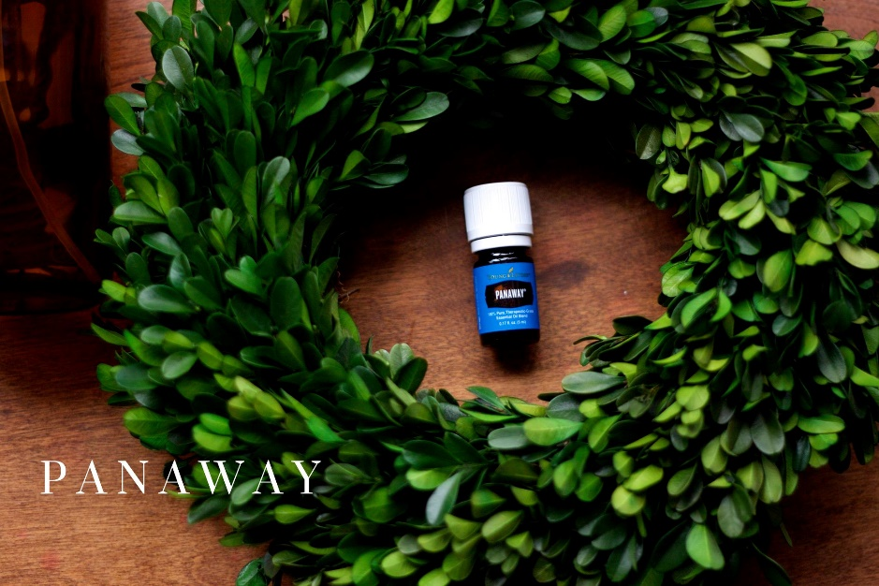

**IMMUNITY ROLLER**

10 Thieves*

10 Lemon*

10 Frankincense* or RC*

Top a 10 ml Roller with Carrier oil for an adult-strength dose of immunity. For 6-12 use ½ the number of drops. Apply to soles of feet or spine daily; twice a day for an added boost!

**Ortho Ease Massage Oil** – designed for a relaxing, soothing massage, a calming blend of vegetable oils with Wintergreen, Eucalyptus, Thyme, Lemongrass, Peppermint, Juniper, and Marjoram.

**Slique Bars** – a mix of exotic fruits and nuts, like baru nuts, almonds, dates, coconut, cacao nibs, Goldenberries, Bing cherries, Wolfberries, Quinoa crips, Chia seeds, and more.

**Tranquil Roll-on** –A mix of Lavender, Cedarwood, and Roman Chamomile. A versatile oil blend for cough & cold relief, muscle pain, headache relief, digestive discomfort, cuts, burns and calming or sleep support.

**Thieves Mints** – will keep breath fresh on the go with sugar-free ingredients alongside the protective benefits of Thieves and Peppermint oils.

**The Desert Mist Diffuser** - diffusion for up to 10 hours and includes eleven light options. I love that it is plastic for travel and yet allows me to have some sleep support away from home. [Desert Mist Diffuser | Young Living Essential Oils](https://www.youngliving.com/en_CA/products/desert-mist-diffuser-ca)

**DIY DRY SHAMPOO**

*For Light Hair*

1/4 cup arrowroot powder

3 drops lavender

3 drops rosemary

*For Darker Hair*

2 TBSP arrowroot powder

2 TBSP raw cocoa powder

3 drops lavender

3 drops rosemary

**DIY BUG BITE ROLLER**

8 drops lavender

8 drops German Chamomile

8 drops Helichrysum

Top up a 10 ml roller with a carrier oil.

**DIY ESSENTIAL OIL WARMERS**

1. Turn Fabric Scraps into a neck or hand warmer. Sew three sides and turn the right side out.

2. Add drops of essential oils to rice in a mixing bowl and mix well.

3. Add the rice to the hand warmer.

4. Sew the opening closed using a needle and thread or dental floss.

Microwave until warm to bring heat to cold hands, sore muscles or a crampy tummy.

**Satin Facial Scrub Mint** - a facial spa in a bottle. Water-based exfoliant with jojoba oil, mango butter, MSM, aloe, and peppermint essential oil to rejuvenate skin.

**DIY ROOM SPRAY**

20 drops of your favourite YL essential oil

1/3 cup water

1 TSBP Witch Hazel

4 oz Glass Spray Bottle

Combine the oils and the witch hazel in the bottle and swirl to mix. Add the water. Shake well before spraying. Replace those chemically-laden air fresheners.

To order, set up a membership by placing an order through my website at <https://getoiling.com/PeggyWright> or reach out to the person who shared this resource with you!